**Participant Name/Alias:**

MANVI

HEALTH/WELLNESS

EDUCATION

FAMILY

CONSTRUCTION

ENERGY

FINANCIAL

AGRICULTURAL

CLIMATE

TOURISM/TRAVEL

ENTERTAINMENT

Very Experienced

No Experience

Fascinated

No Interest

CYBER SECURITY

ORGANISATION ENABLEMENT

GAMING

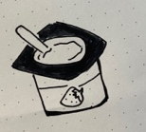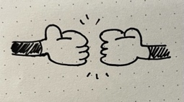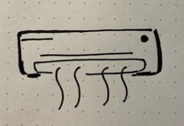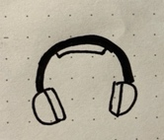

**Participant Name/Alias:**

Manvi